Software Requirements Specification
BE Projects 2011-12

Autonomous Artistic Robot (AARo)

VINEET KAKATI
GANESH DHURI
BHAVESH KHETPAL
Table of Contents

1. Introduction 3
1.1 Definitions, Acronyms and Abbreviations 3
1.2 References 3
2. Overall Description 4
3. Details 6
3.1 Functionality 6
3.2 Supportability 7
3.3 Design Constraints 7
3.4 On-line User Documentation and Help System Requirements 8
3.5 Interfaces 8
3.5.1 User Interfaces 8
3.5.2 Hardware Interfaces 9
3.5.3 Software Interfaces 9
3.5.4 Communications Interfaces 9

4. Quality control 10
5. Risk Management 10
5.1 Risk 10
5.2 Mitigation Plan 11

Introduction
An artist robot is a specialized autonomous mobile robot that is used to recreate different images as per given input. In this SRS we describe functionality and requirements along with Risk Analysis.

Definitions, Acronyms and Abbreviations

  - Robot :- A robot is a mechanical and electronic device which is designed to perform a specific task. A robot may perform a task under the guidance of a human or on its own.

  - Autonomous robot :- An autonomous robot is a robot capable of performing tasks on its own (without assistance of human).

  - Swarm :- Swarm is a group of robots which are co-ordinated to perform a task together.

References

  - www.wikipedia.org
  - Spark V manuals
  - http://paintwithrobots.fr.mu

Overall Description

Product Perspective
Designing and developing a method for processing image data into commands for motion control for autonomous artistic robot swarm.

Product Functions
Autonomous artistic robots capable of recreating the image at proper corresponding location as per input on the canvass.
The robot swarm consists of three robots controlled and co-ordinated by central control computer.

User Characteristics
  - The user involved has to do the work of starting the system.
  - Once the system starts the robots create the image autonomously.
  - Once the image has been produces ,the system (i.e. robots) stops automatically.
  - Users are mostly spectators or art enthusiasts.

Constraints
  - Limited number of colours for creation of images.
  - Images particularly those with curves cannot be recreated perfectly.

Assumptions and Dependencies
Robots are dependent on central camera for capturing the image of physical canvass initially so that digital co-ordinates can be mapped to physical co-ordinates. They don’t possess individual cameras for keeping track of their position.
The robots don’t have individual intelligence, they are controlled by a central controller takes the digital image as input and returns commands to robots via wireless medium for motion control.
Each robot has a colouring utility attached to it which may be green, red or blue. The colouring utility is attached to robot by means of a servo motor .The colouring utility can me moved up and down.

Requirements Subsets
- A White sheet of paper is to be used as canvass on which robots will recreate digital image.
- Proper suspension of camera over the canvass so that proper mapping of digital co-ordinates to physical co-ordinates can be done..
- A central controller which is equipped with image processing and algorithm for converting the image (i.e. image matrix) to motion control commands which are communicated to the robots via a wireless medium.

Details

Functionality
An Artistic robot is a specialized autonomous and mobile robot that is used to create different types of images
Image processing will be used for position on image on canvass as well as for obtaining the motion control code from the input image.
Once input image has been processed the central controller communicates the instructions to the proper bot depending on colour of image. This continues until the image has been created completely on canvass.
ZigBEE protocol will be used for communication with the robots.
The information flow diagram below shows how information will flow through various modules of the system.

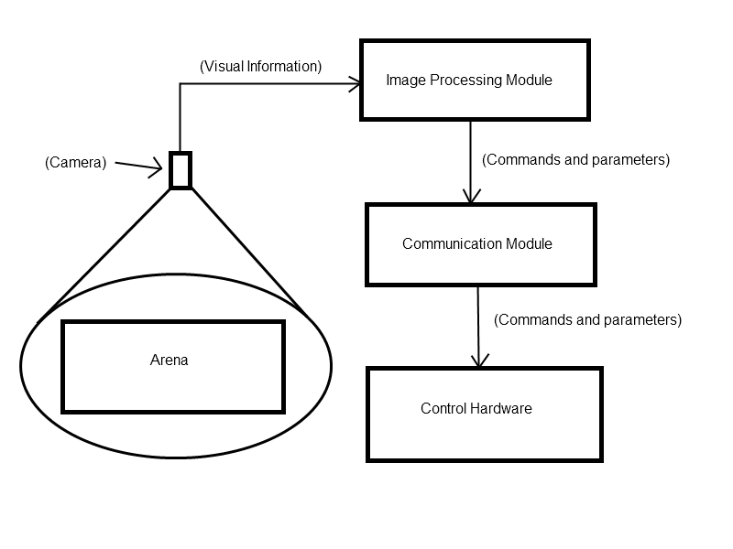
Canvass

Supportability
Standard Coding and naming conventions are used. We are using Win AVR for programming the robots in C. MATLAB is used for Image processing along with its image processing toolkit.

Design Constraints
- Accurate reproduction of curved images may not be possible under the current design plan of the robotic arm like attachment.
- The bot’s limited movements would also pose certain challenges when it comes to actual implementation.

On-line User Documentation and Help System Requirements
Entire code, which would be developed during the project will be appropriately documented and will be made available online for public reference.

Interfaces

User Interfaces
The user is system operator. Initially the user gives the start command to the system, the robots will then start colouring the image and when images are completely coloured the respective bot, the user stops the system with an end command. Intermediate User interfaces are not used in the project as the robots would be autonomous.

Hardware Interfaces
In extra hardware interfaces we are going to use robotic arm which supports the colouring utility(i.e capable of holding a pen or a marker).

  - Software Interfaces
Extra software components are not needed, we will write the image colouring algorithm by ourselves.

  - Communications Interfaces
Communication is between the central controller and robots using ZigBEE. No other LAN networks needed.
One command is associated with each action that can be performed by the robot.
Ex. for moving the robot forward we will transmit the command ‘FW’ followed by angle of rotation and number of rotations to be made.

Quality Control

Test Data

The robots are capable of following actions:

Communicate: Communicate with the central controller to determine the image to which it is responsible for colouring.

Mapping & adjustment: identify position on canvass ,avoid collision and overlapping, colouring of the respective image.
  - Pen up & down: the servo motor must move as directed via the program , i.e. either up or down as required.
  - Test Drawing: initially the robots will be tested for drawing straight lines and performing turns. Later proper shapes etc will be given to it for drawing.

Risk Management

Image processing risk

We may not reach that much accuracy and can failover to draw the curves and complex shapes.
Also,it might be difficult to handle the variations in a single colour by using MATLAB as it can increase the complexity during image processing.

Mitigation plan

We are trying to draw the basic geometrical shapes like square, rectangle etc.
Also, instead of using different contrasts of a single colour ,we are focussing on the basic colours i.e. Red ,Green, Blue.

